Steps to create first pipeline:  
  
1. Click on new item :

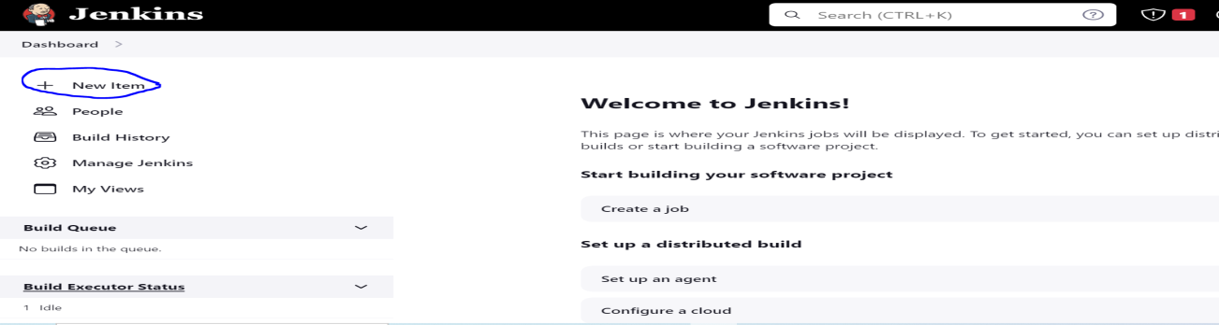

2. Enter Job Name and select project as Freestyle project.  
  
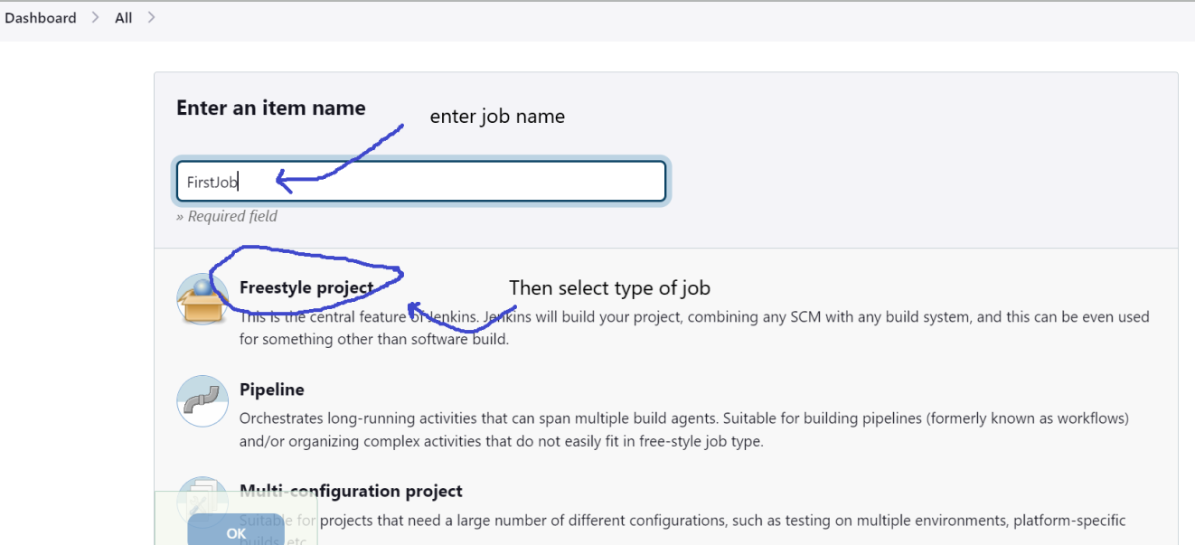

3. To Integrate Git select **Source Code Management**.  
  
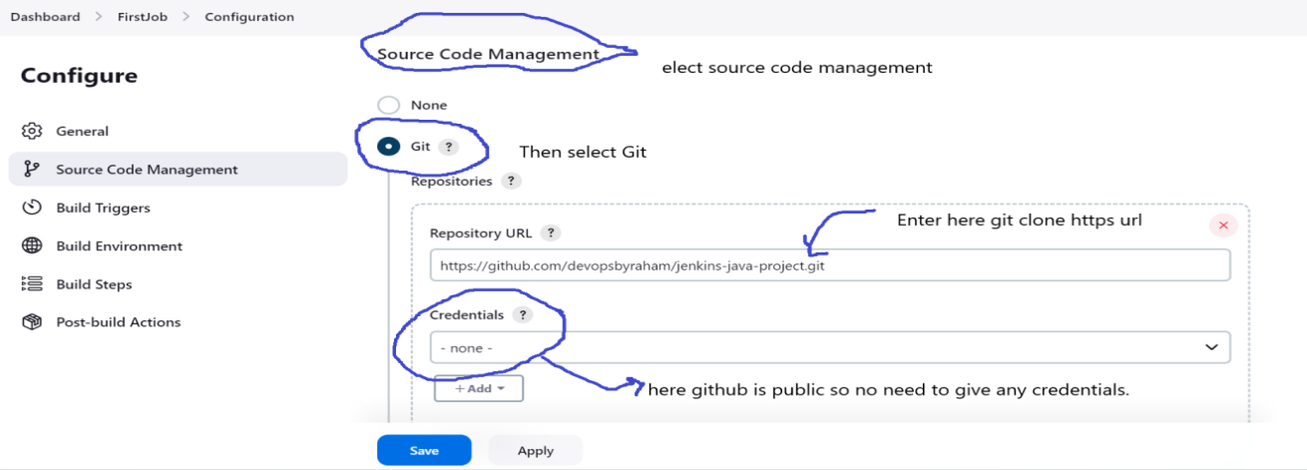

4. Goto **Branches to build** and enter your branch name which you want to build.

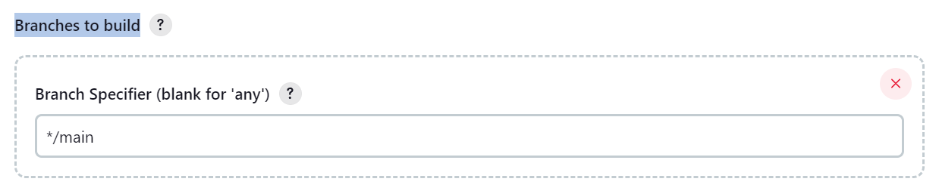

5. To Integrate Maven select **Build Steps**.  
  
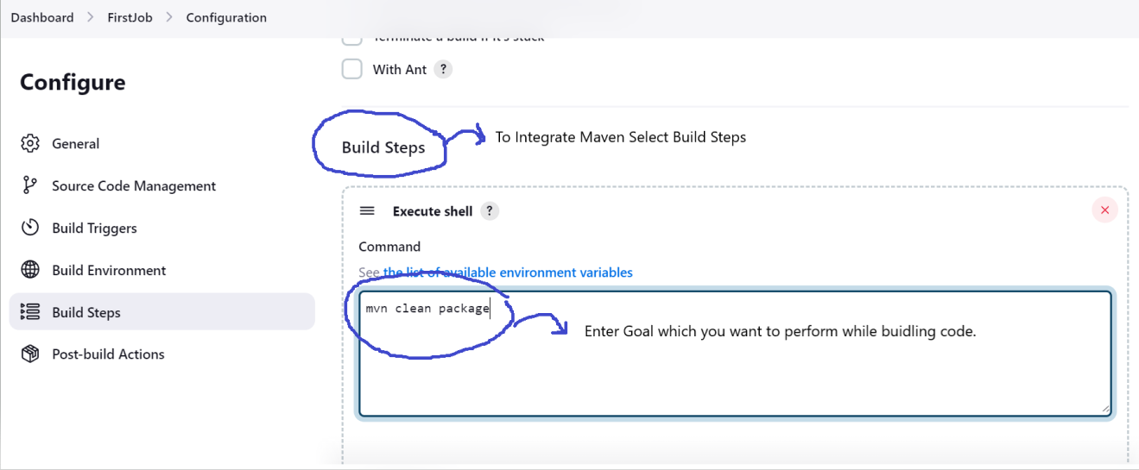  
  
6. Then click on save or apply.  
7. To trigger build click on Build Now.  
  
